7.51: 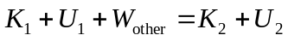
Point 1 is where he steps off the platform and point 2 is where he is stopped by the cord. Let 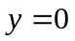 at point 2. 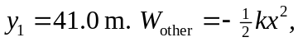 where 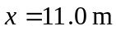 is the amount the cord is stretched at point 2.The cord does negative work.
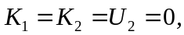 so 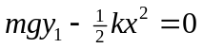 and 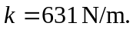
Now apply 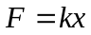 to the test pulls:
so 